**Abstarct**

This project is a Windows Forms application developed using C# and SQLite, designed to simplify school management.

**Acknowledgement**

I sincerely Thank to My Lecturers, lab assistance, faculty, and all who supported me in completing this project successfully. Special thanks to the UnicomTIC for providing the necessary resources and encouragement throughout this journey.

This experience has enhanced my skills in C#, database design, and MVC architecture, Control, and has helped me understand real world software development practices.

**Objective**

To develop a Windows-based school management application with role-based login for Admin, Lecturer, Student, and Staff. The system allows each user to access only relevant features, making the application secure and user-friendly.

**Project Structure**

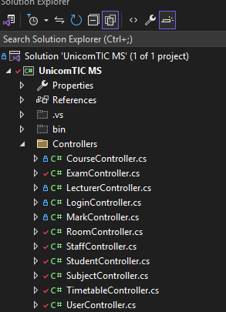

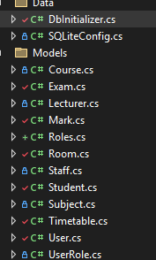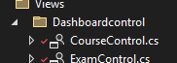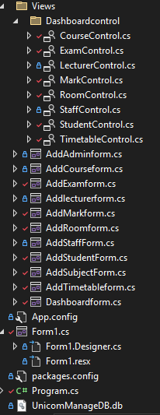

**This ER diagram illustrates the database structure of the School Management System.**

The central users table maintains the general user information, linked with role-specific tables like student, staff, lecturer, and admins.

Academic structures such as course, subject, exam, and mark are interrelated, supporting functionalities like course management, examination handling, and result tracking.

The timetable table connects subjects and rooms, while the room table specifies room details such as lab or lecture hall types.

All primary and foreign key relationships are clearly represented to maintain data integrity and normalization.

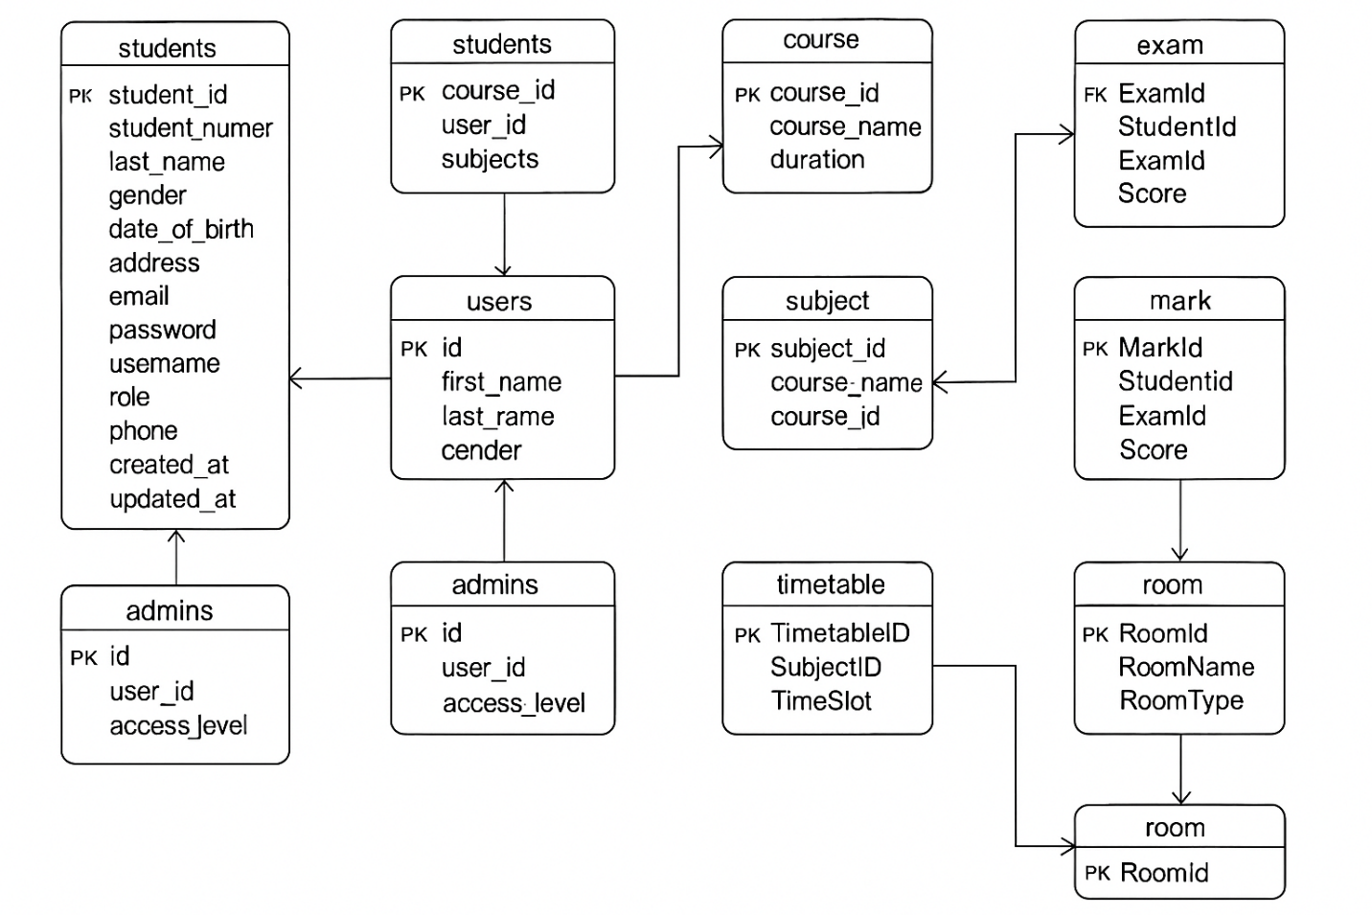

**Functional Requirements**

* Role_based and dashboard
* Secure data handling using SQLite

**Conclusion**

This project provides an efficient and secure way to Manage school data using Role_based access. It demonstrates strong fundamentals in Windows Forms development, MVC architecture, and database interaction using SQLite.

Submitted By:

Nivethiga Sivakadacham |UT010558| UnicomTIC / 2025